The universe (answers)

Instructions to students  • You have 50 minutes to complete the test.  • Please answer all questions in the spaces provided.  • There is to be no talking during the test. | Marks  Section I: Multiple-choice questions: 10 marks  Section II: Short-answer questions: 35 marks  Section III: Extended-response questions: 5 marks  Total: 50 marks

Name: ________________________________________________________  Class: _________________________________________________________ | Score: /50  Grade: %
Comments:

Section I: Multiple-choice questions
For each question, circle the correct answer.

1 Our Sun is part of the galaxy known as: |  | 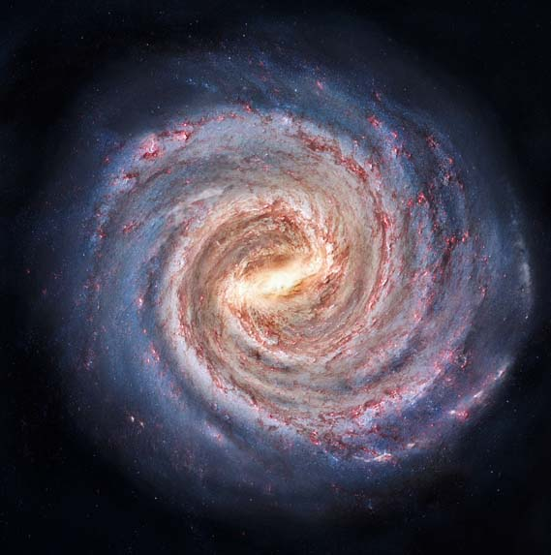
A | the milky way.
B | Orion.
C | Proxima Centauri.
D | Andromeda.
2 The more negative the absolute magnitude of a star, the:
A | cooler it is.
B | brighter it is.
C | hotter it is.
D | dimmer it is.
3 When a star explodes and releases bright light and energy, it is called a:
A | main separation.
B | black hole.
C | supernova.
D | quasar.

4 If the radius of the Earth's orbit is known, the distance to star A can be calculated by measuring X.
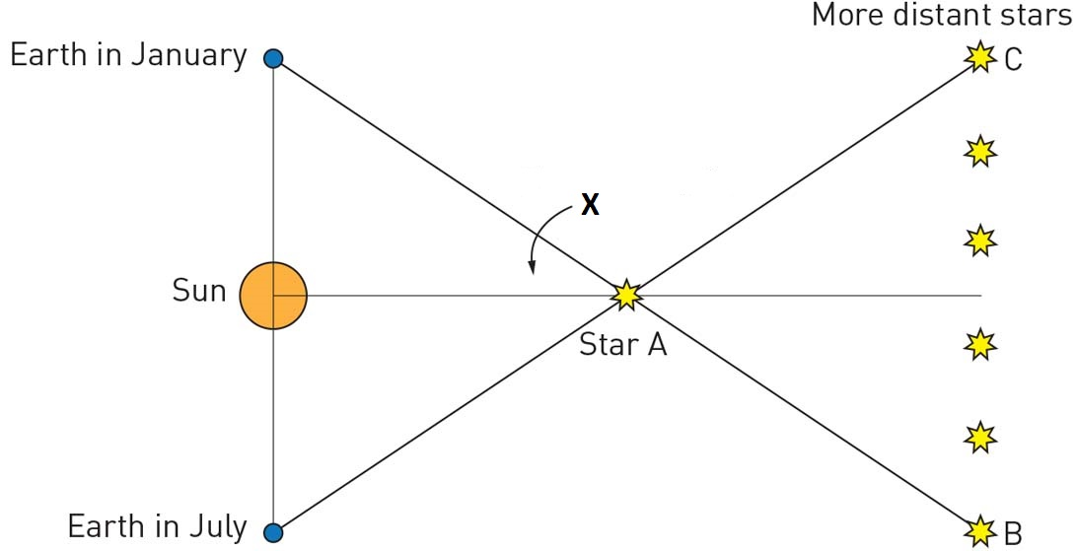
X is the:
A | apparent magnitude angle.
B | absolute magnitude scale.
C | radius of the Earth’s orbit.
D | parallax angle.
5 The conclusion from Hubble’s Law is that:
A | we are at the centre of the Universe.
B | the more distant galaxies are travelling the fastest.
C | everything is moving away from Earth.
D | the further a galaxy is away from Earth, the slower its speed.
6 A star is 6.62 × 10¹⁴ km away from Earth. Approximately how many light years distance is this if one light year is 9.46 × 10¹² km?
A | 7000
B | 70
C | 7
D | 700

7 Cosmic microwave background (CMB) radiation is evidence for the:
A | Cyclic theory of the Universe.
B | Big Crunch theory of the Universe.
C | Big Bang theory of the Universe.
D | Steady State theory of the Universe.
8 The change in wavelength of sound waves emitted from a moving sound source is known as:

A | the Doppler effect.
B | red shift.
C | Einstein’s equation.
D | Hubble’s Law.
9 The colour of a star depends on:
A | its age
B | its size
C | how far away it is
D | its surface temperature

10 On the Hertzsprung–Russell diagram the diagonal line from top left to bottom right represents the:
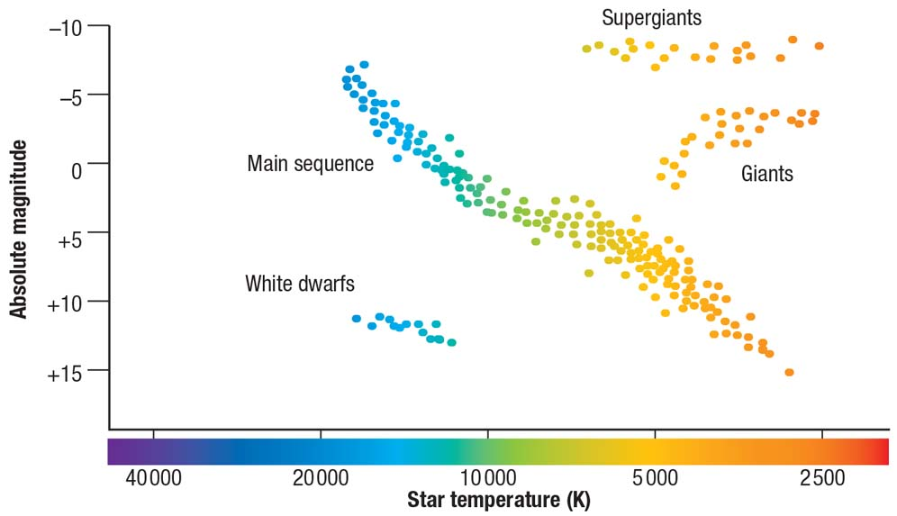
A | main sequence.
B | red giants.
C | star sequence.
D | main separation.
Section I total marks:
/10 marks

Section II: Short-answer questions
11 The weightlessness astronauts experience in space can weaken bones and muscles so much that they are unable to stand up when they return to Earth. How is this problem now managed?

They exercise before and during space missions.
/1 mark
12 Determine if each of the following in the list below is a constellation, star or galaxy.
• Sun
• Milky Way
• Orion
• Proxima Centauri
Constellation: Orion
Star: Sun, Proxima Centauri
Galaxy: Milky Way
/4 marks
13 What are galaxies and how do we classify them?
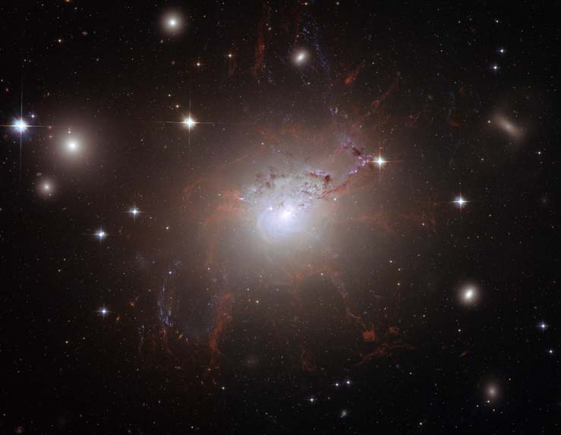
Galaxies are groups of billions of stars held together by gravity (1 mark). They are classified according to their shape (1 mark), which is spiral, irregular or elliptical.
/3 marks
14 Proxima Centauri is located outside our solar system at 4.2 light years away. Explain what this distance means.
This means light takes 4.2 years to reach Earth from Proxima Centauri. We would see anything, such as an explosion, 4.2 years after it has occurred.
/2 marks
15 Two stars in the night sky appear to be the same brightness. Are they the same distance from Earth? Explain your answer.
No, not necessarily. Explanations will vary. One possible answer is that one of the stars might be a dim star that is very close to the Earth while the other is a very bright star that is further away.
/2 marks
16 A racing car makes a ‘yeee … owww’ sound as it speeds towards and then past an observer.
a Choose the correct terms in the following statement, relating the sound to the blue and red shift of the Doppler effect and to the movement of galaxies towards and away from us.
The ‘yeee’ is a higher/lower frequency, which corresponds to a blue/red shift in light, which indicates movement towards/away from us.
a The ‘yeee’ is a higher frequency, which corresponds to a blue shift in light, which indicates movement towards from us (1 mark for each correct).

b The pitch of the racing car changes as the car drives past the observer. Is this change noticeable by the driver of the car? Explain your answer.
b No (1 mark). It is only an apparent change OR it is only noticeable by a stationary observer (1 mark).
/5 marks

17 Describe how Indigenous Australians used the Milky Way to determine times of the year for hunting emus and collecting eggs.
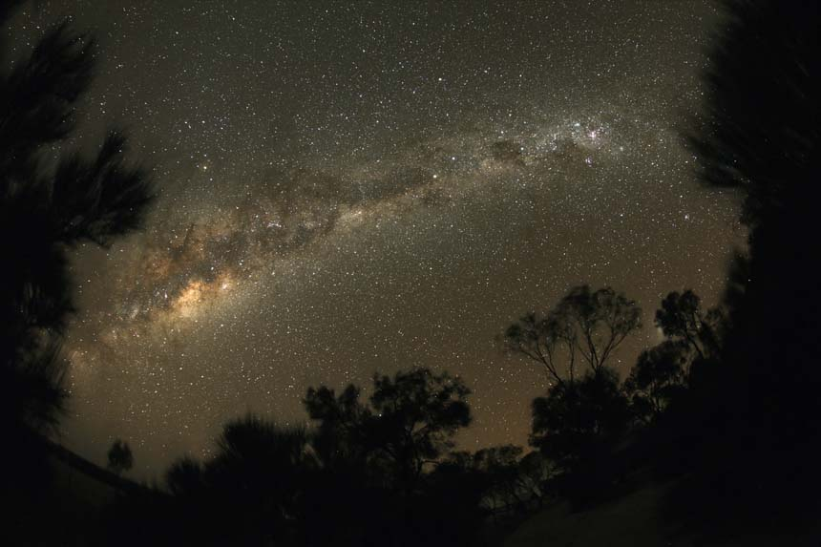
Within the Milky Way there is a dark patch that looks like an emu (1 mark). At certain times of the year the emu looks like it is running; this indicates a time to hunt emu (1 mark). At other times the emu looks like it is sitting; this indicates a time to collect emu eggs. (1 mark)
/3 marks
18 The apparent magnitude of our Sun is –27 while its absolute magnitude is +4.8. What do these two numbers tell us about our Sun?
The –27 tells us the Sun is very bright when viewed from Earth. The +4.8 tells us the Sun is not a very bright star when compared to all other stars.
/2 marks

19 Label the x-axis on the Hertzsprung–Russell diagram below. Which of the four bands (A, B, C or D) represents the white dwarfs?
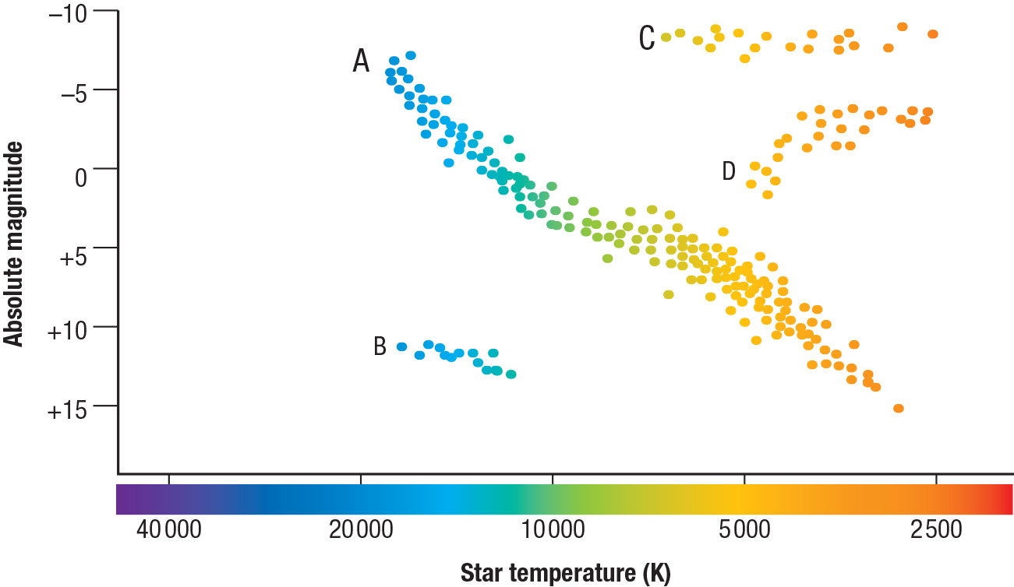

Band B represents white dwarfs
/2 marks
20 Arrange the following stages in the life cycle of a star in the correct order from earliest to latest:
red giant, white dwarf, main sequence star, black dwarf
main sequence star, red giant, white dwarf, black dwarf
/4 marks
21 Draw a line matching each scientist to the contributions they made to our understanding of the universe.

/3 marks
22 Why can’t the distance to distant stars (beyond 100 light years) be measured using stellar parallax?
The more distant a star, the less parallax it shows, and the more difficult to measure and determine its distance
/2 marks
23 Describe how cosmic microwave background radiation provides evidence that supports the Big Bang theory.
The Big Bang theory relied on the idea of the existence of some sort of radiation. It was hypothesised that the large amounts of heat released would still exist in a much cooler form. This leftover energy existed as background radiation or CMR.
/2 marks
Section II total marks:
/35 marks

Section III: Extended-response questions
24 Outline how nuclear fusion is able to occur within a nebula, resulting in the birth of a star.
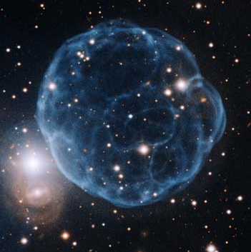
Nebulae are large clouds of hydrogen gas (1 mark). The nebulae are attracted to each other by gravity (1 mark). The hydrogen atoms in the centre of the cloud are under a great deal of pressure, causing the centre of each nebula to heat up (1 mark). Eventually there is enough heat and pressure to fuse two hydrogen atoms together, forming helium (1 mark). This nuclear fusion releases large amounts of energy in the form of heat and light, resulting in the birth of a star (1 mark).
/5 marks
Section III total marks:
/5 marks

